Lab 9: Database Design III - CRUD Pt. 2(8% of total grade)
Submission: Put your answers under each question, then submit this document as a PDF file to Blackboard (Assessments > Lab 9 - Database Design III CRUD Pt. 2).
Name your file: HTTP5126-L9-CRUD-Pt2-LastNameFirstName.pdf, replace LastNameFirstName with your name as displayed in Blackboard.
Purpose: To practice CRUD functionality using SQL.
Requirements: For this assignment, you will use the provided Entity Relationship Diagrams to create tables and then use SQL to alter or delete some of those tables.
NOTE: Run your queries on your database to make sure desired results are achieved. Also import and execute your sql file to ensure it runs all your queries before submitting. Each letter of each part should contain a single query.

Pre-Lab:
- Start your MySQL server and open phpMyAdmin.
- Use the database you created for last week’s lab. The diagram for how the database should look is at the bottom of this document for you to reference.

Part 1: [U]pdate (2.0%)
- Alter the product table by adding a constraint to the price column that checks for all new products to have a price value equal to or over 0. [0.4%]
- Jane meant to order the Canon Camera instead of the Apple Smartphone, update the order_product table to reflect this change. [0.4%]
- Update all ‘Smartphone’ products in our products table to instead have the name ‘Cellular Device’. [0.4%]
- John has changed his email to ‘john@outlook.com’ in our system. Update all his records to reflect that change. [0.4%]
- Due to inflation, update the price for the Herman Miller Chair to be $600. [0.4%]

Part 2: [D]elete (1.0%)
- Our supplier no longer offers us Dell Laptops. Delete it from the products table. [0.33%]
- John's orders have been delivered, delete rows from the order_product table that are related to John. [0.33%]
- Also delete rows from the order table that are related to John. [0.34%]

Part 3: Using all of CRUD (5.0%)
- We have a new supplier called ‘North Digital Supplies’. They carry three products: a Lenovo Laptop for $800, an Apple Macbook Laptop for $1000, and a Nintendo Switch 2 Gaming Console for $800. Add the supplier and their products to the database. [1.25%]
- Now that that has been added, I want to see all the products our store offers, including the supplier for each product. Write a query that will return this information. [1.25%]
- ‘North Digital Supplies’ is going out of business and is having a liquidation sale. Update the Lenovo Laptop to be $400, the Apple Macbook Laptop to be $500, and the Nintendo Switch 2 Gaming Console to be $400. [1.25%]
- Whoops, ‘North Digital Supplies’ has gone out of business. Delete their record and all of their products from our database. [1.25%]

Appendix

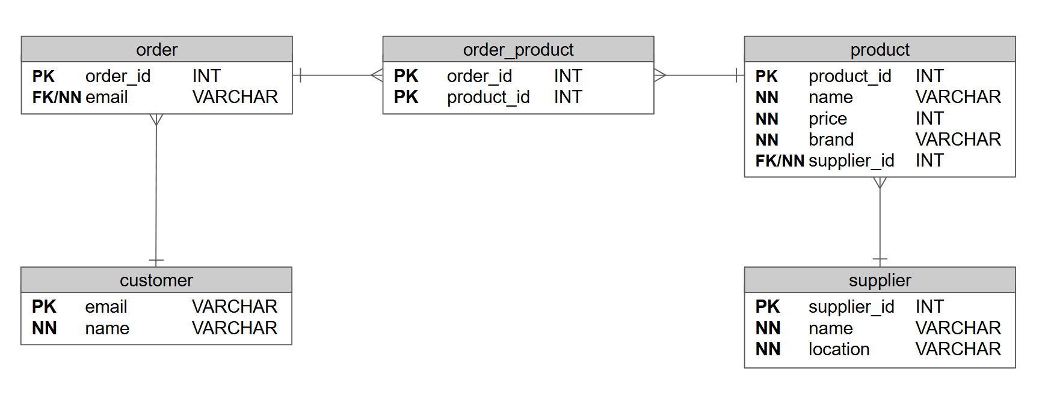
Part 1: Use the Entity Relationship Diagram below to complete this lab

Part 2: Use the data in the tables below to populate your created tables from Part 1
